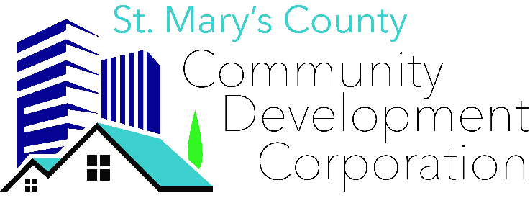
46940 S. Shangri-La Drive, Suite 7
Lexington Park, MD 20653
301-863-7700
execdirector@stmaryscdc.org

DONATION FORM
Thank you for choosing to make a donation to St. Mary’s CDC! We appreciate your support of our mission. Please indicate the specific project or program to which you would like your donation allocated. Please complete the form entirely. If you are mailing a check, follow the instructions below.
Donor Name:
Email:
Phone:
Mailing Address:
DATE | DESCRIPTION | TOTAL
TOTAL

Tax ID: 52-1441453
- If donating to a specific cause, include the cause on the check’s memo line. Disregard if submitting a general donation.
- Please return this form along with payment, even if you donated online.
- Ensure checks are payable to St. Mary’s County Community Development Corp. or donate online at stmaryscdc.org.
If you have any questions, contact Taylor Smith.
Office: 301-863-7700. Email: ExecDirector@StMarysCDC.org.

